1. Design Instagram

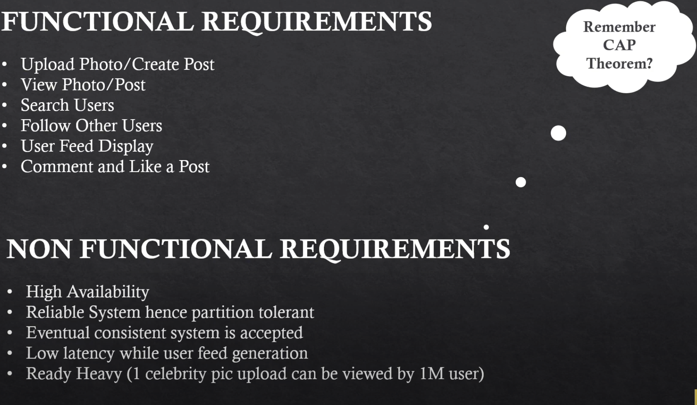

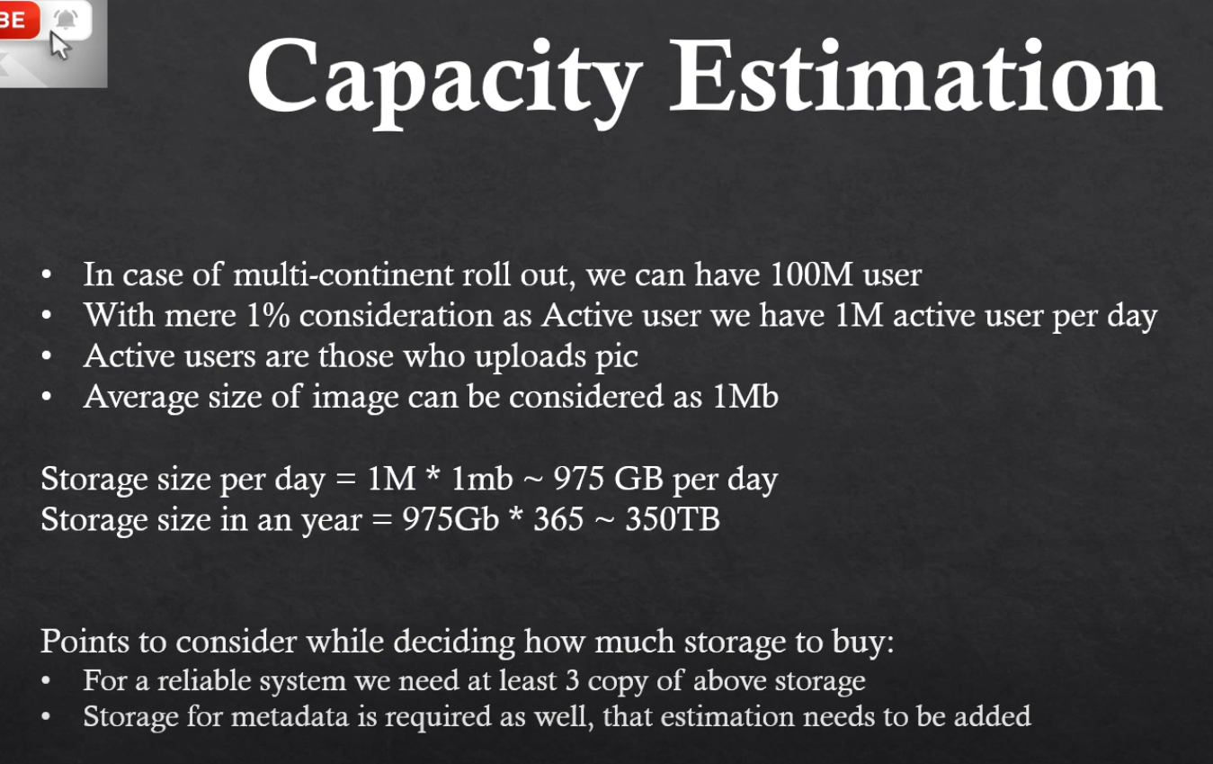

* 1. Photo Update

Store photos in Distributed file system and update metadata, use CDN to deliver photos at different geographical locations.

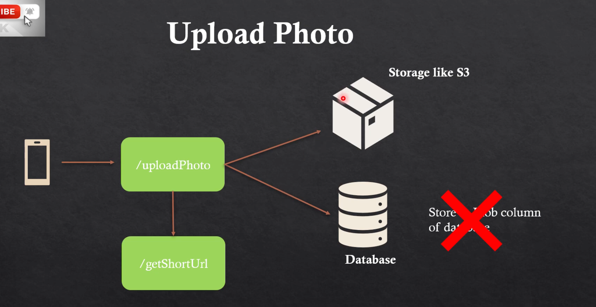

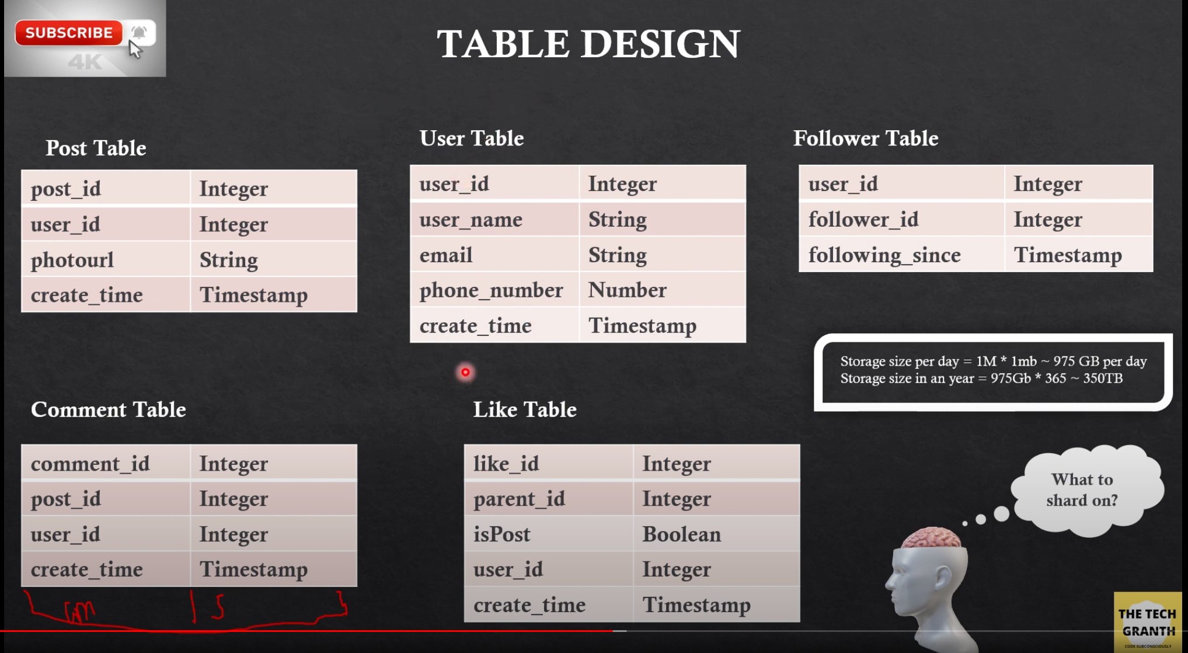

Shard on postId makes more sense than sharding on userId as few users can have more posts/uploaded but few may not. If we shard on postId, postId will be distributed evenly among available nodes.

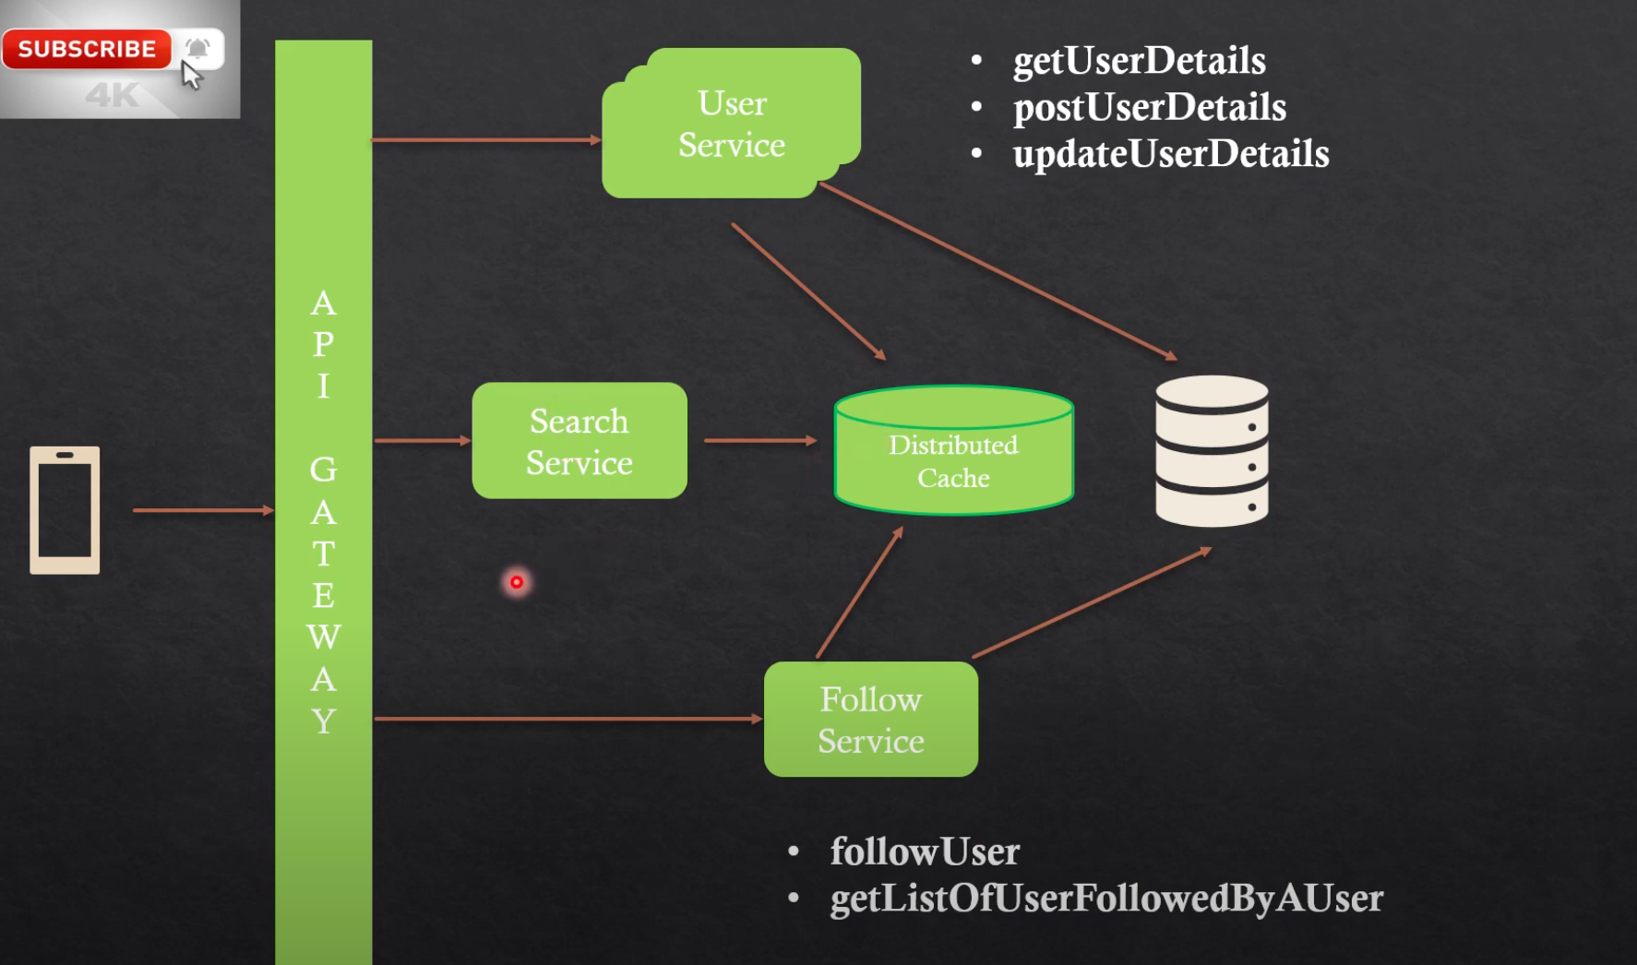

* 1. Feed – User feed need to be precomputed to achieve low latency
     1. For every post, event will be triggered, FeedService will listen to that event and build a distributed cache for all the followers. As soon user logs in his readily available feed will be served from cache.
     2. For celebrity users(Users having lot of followers(1M+), it is not practical to build cache for all users, hence we have to go for hybrid solution where we will not populate cache for celebrity users posts instead we just populate cache for normal users post. Whenever user logs in we just pull posts from celebrity users and combine with normal followers post for the logged in person and feed page will be populated.
     3. In case of cache miss, DB call is the option but if cache miss happens to lot of people then subsequent DB calls will be executed and which will increase the load. In such cache miss cache we should come up with Promise based cache and all users should be listening to Promise based cache and one DB call is enough and one completion all users will get the feed.

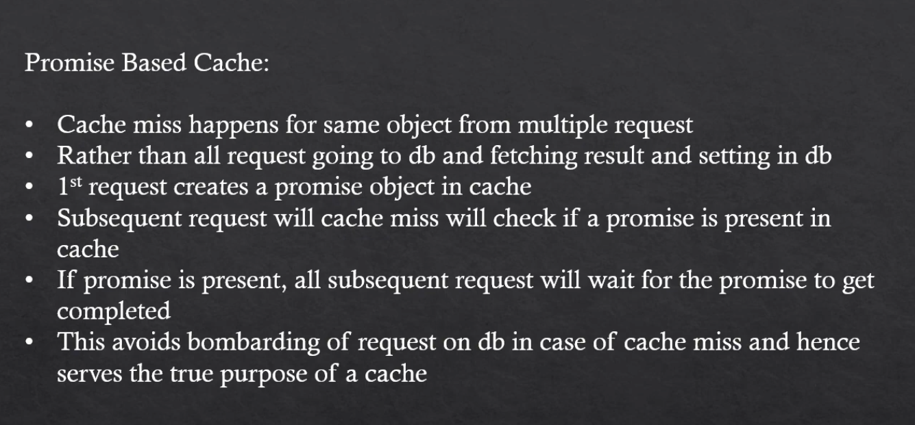



For likes, it is better to have one “like” table with like_id, post_id, liked_by etc for persisting every like transaction and keep updating cache (write through) cache and have reconcile_job running for every hour and populate “like_aggregated” table with count of likes and update cache accordingly.

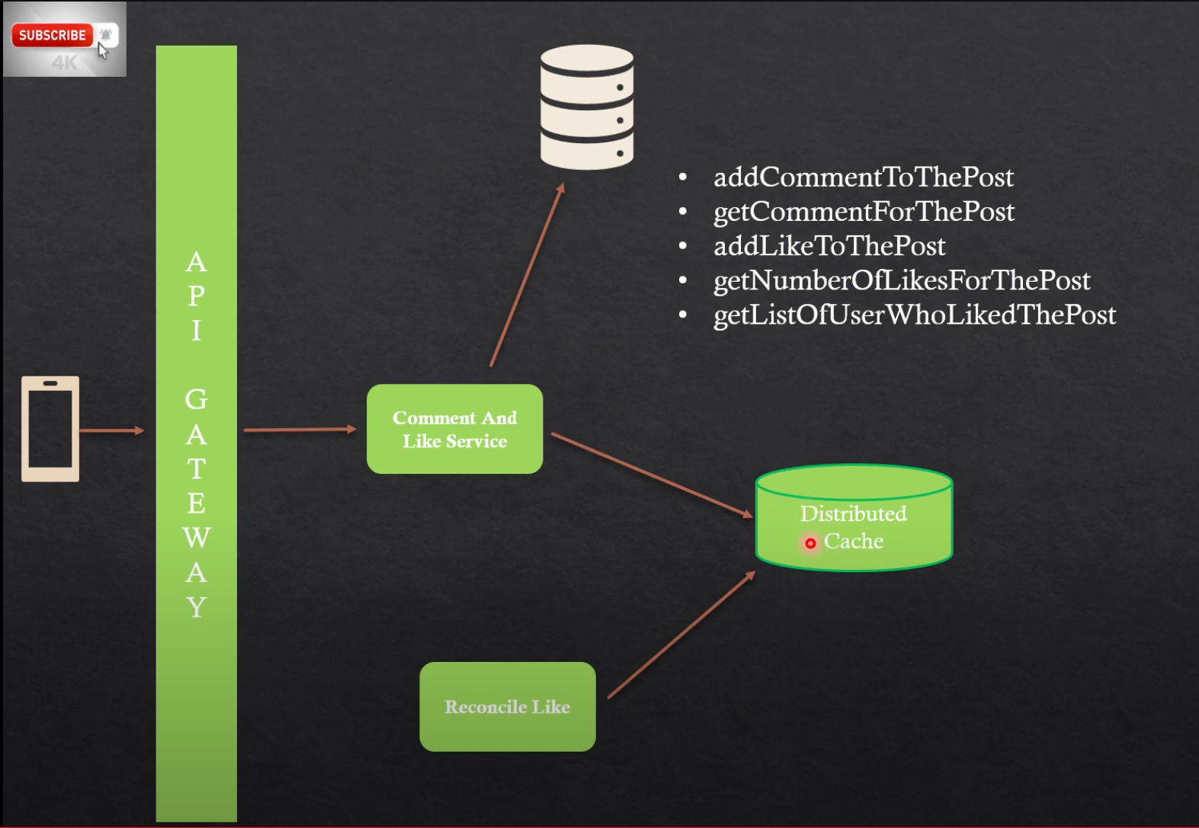

1. Design Tiny URL

Get the traffic volume to serve. 62^n is the common formula to calculate volume to serve, here n is length of url. Ex: 62^7 ~= 3500 billion URLs.

DB

id, short_url, long_url

Approaches

* 1. Generate random url and save.

Pro: simple working solution

Disadvantage: High chance of collision

* 1. Generate random URL & insert, if collision retry again till it succeeds.  
     Pro: Simple and avoids collision.

Cos: Not practical solution when serving distributed system.

* 1. Generate ID from workerID(7Bit), TimeStamp(43 bit till milliseconds), Sequence/Random number(8bit)  
     This is more than 62^7 I.e. 2^58 is more than 62^7 hence not useful. If you reduce the bits then more chance of duplicates. This approach guaranty less duplicates but it’s not bug free.
  2. Insert into DB every time and get unique id and update short url.  
     Pro: Bug free  
     Cons: Not suitable for distributed system as there is bottleneck on Insert & update.
  3. Range numbers:   
     How It works -   
     ID generation service - Every worker id(Totally 64 workers) will initially get range from DB(Say million users once), for every subsequent request get one count from range and respond. With this there is always unique numbers generated. Id generation can be separate service or it can be generated within same short url generation service. Insert into DB next range used as below and use auto_increment column to generate range while inserting as we can know from query what is next id and use that number to generate range and mark it as used.

|  |  |  |  |
| --- | --- | --- | --- |
| ID | Range | Status | Worker id |
| 1 | 0 – 1M | Used | 1 |
| 2 | 1M – 2M | Used | 64 |

Pro: Suitable for distributed system

Cons: In case of loss of worker machine, we will lose max 1Million of range

1. Rate Limit

A rate limit system is a key component in any application or system that handles a large volume of requests from multiple sources. It is responsible for ensuring that the system remains stable and performs well, by limiting the rate at which incoming requests are processed.

Here are some key considerations for designing a rate limit system:

1. Determine the scope: Decide what resources or endpoints need to be rate-limited, and what constitutes excessive requests.
2. Decide on the rate limit algorithm: There are several rate-limiting algorithms, including token bucket, leaky bucket, and fixed window. Choose the algorithm that best suits your needs based on factors such as scalability, accuracy, and ease of implementation.
3. Set the rate limit: Based on the algorithm you have chosen, decide on the maximum number of requests that can be processed within a given time window (e.g., 100 requests per minute).
4. Implement the rate limit: You can implement the rate limit system within your application code or use a third-party service. If you implement it yourself, ensure that you use a distributed system to handle rate limiting across multiple instances of your application.
5. Provide feedback to users: When a user exceeds the rate limit, provide meaningful feedback to inform them of the reason for the rate limit and when they can expect to be able to send requests again.
6. Monitor and tune: Continuously monitor the performance of your rate limit system and adjust the settings as needed to optimize performance and prevent abuse.

Overall, designing a rate limit system requires careful consideration of the scope, algorithm, rate limit settings, implementation, feedback to users, and ongoing monitoring and tuning to ensure optimal performance.

Token Bucket, Leaky Bucket, Fixed Window, and Sliding Window are all algorithms used for rate limiting incoming requests.

1. Token Bucket Algorithm: This algorithm works by maintaining a "token bucket" that is filled with a fixed number of tokens over time. Each incoming request consumes one token from the bucket, and if there are no tokens left, the request is rejected. This algorithm is useful for handling bursts of traffic as unused tokens are stored in the bucket, allowing for bursts of traffic to be processed quickly.
2. Leaky Bucket Algorithm: This algorithm works by imagining a "bucket" that can hold a fixed amount of water. Water is added to the bucket at a fixed rate, but if the bucket overflows, the excess water is discarded. Similarly, requests arrive at a fixed rate and are processed if there is enough "water" (or capacity) in the bucket. This algorithm is useful for ensuring a consistent rate of traffic.
3. Fixed Window Algorithm: This algorithm divides time into fixed intervals (e.g., 1 second), and each interval has a maximum number of requests that can be processed. Once the limit is reached, any further requests are rejected. This algorithm is simple to implement but can be less effective in handling bursts of traffic.
4. Sliding Window Algorithm: This algorithm is similar to the fixed window algorithm but uses a sliding time window. A sliding window divides time into fixed intervals, and a new window starts every time interval. Requests that arrive during a window are processed, and once the limit is reached, any further requests are rejected until the next window starts. This algorithm provides better handling of bursts of traffic as it considers requests over a rolling time window.

Overall, the choice of algorithm depends on the specific requirements of the application or system and the trade-offs between factors such as accuracy, scalability, and ease of implementation.

Both fixed window and sliding window rate limiters are used to limit the rate of incoming requests to a system or application, but they differ in how they define and enforce time intervals.

The fixed window rate limiter divides time into fixed intervals (e.g., 1 second) and sets a limit on the maximum number of requests that can be processed within each interval. Once the limit is reached, any further requests are rejected until the next interval starts. For example, if the limit is set to 100 requests per second, and 110 requests arrive in the first second, 100 requests will be processed, and the remaining 10 requests will be rejected.

The sliding window rate limiter also divides time into intervals, but the intervals slide forward over time. For example, if the interval is set to 1 second and the limit is 100 requests per second, the rate limiter will maintain a moving window that looks back over the previous second and enforces a limit of 100 requests within that window. Any requests that exceed the limit within the sliding window will be rejected. This approach allows for more flexible and precise rate limiting, as it considers the number of requests over a rolling time window instead of discrete time intervals.

In summary, fixed window rate limiters provide a simple and easy-to-implement approach to rate limiting, while sliding window rate limiters provide more granular control over the rate of incoming requests and are better suited to handle bursts of traffic. The choice of rate limiter depends on the specific requirements of the application or system and the trade-offs between factors such as accuracy, scalability, and ease of implementation.

1. Collaborative editing – Like google docs

Product requirement(Functional)

* 1. Collaborative editing
  2. Version history
  3. Share document
  4. Update etc

Engineering requirement(Non Functional)

Availability, Scalability, reliability etc

In a collaborative editing system, conflicts can arise when multiple users try to make changes to the same part of a document simultaneously. Conflicts need to be resolved to maintain the integrity of the document. Here are some common conflict resolution strategies:

1. Locking mechanism. Pessimistic locking(Not allowing more than one person to edit) is not good is not good approach to follow here. We should follow optimistic locking as below options.(Allowing users to edit shared resource and making decision while saving, either by communicating or deciding best edit by own).
2. Last Writer Wins (LWW): In this strategy, the latest change made by a user is accepted as the correct change, and all earlier changes are discarded. This strategy is simple to implement, but it can result in loss of data if a valuable change is overwritten by a later change.
3. Operational Transformation (OT): This strategy aims to preserve all changes made by users and applies them to the document in the correct order. OT algorithms transform each operation made by a user to reflect the changes made by other users. This strategy requires more complex algorithms and data structures, but it can preserve all changes made by users.
4. Three-way Merge(Differential Sync): This strategy compares the original version of the document, the version edited by one user, and the version edited by another user to create a merged version of the document that contains the changes made by both users. This strategy requires identifying the changes made by each user and merging them into a single document. This strategy can be complex to implement, especially for longer documents with many changes.
5. Conflict Detection and Resolution by Human Intervention: In some cases, it may be appropriate to involve a human operator to resolve conflicts. This can be done by notifying the users of the conflict and asking them to resolve it manually. This strategy requires more time and effort but can ensure the highest quality conflict resolution.

In conclusion, different conflict resolution strategies have different trade-offs in terms of simplicity, accuracy, and effectiveness. The strategy chosen depends on the specific requirements of the collaborative editing system and the desired level of control over conflict resolution.

1. Design system like Dropbox/One Drive  
     
   Product requirement
   1. File Upload/Download
   2. Sync files between different devices
   3. Partial edit and upload functionality

Non Functional

1. Should be able to upload large files upto 1GB – use chunks

Client :

Components:

**Observer** – Observe if any file is added into File folder mapped to client.

**Chunker** – chunks file into smaller size, Size is configurable.

**internal DB** – to store file metadata information like fileId, fileChecksum, chunkId(s), chunk_checkum, IndexId(s) etc.

**Indexer –** Indexer is the component which uploads chunks to server and keep track of Successful/errors(For Rety) in internal DB.

Note : Mobile client will also have similar setup like Desktop client.

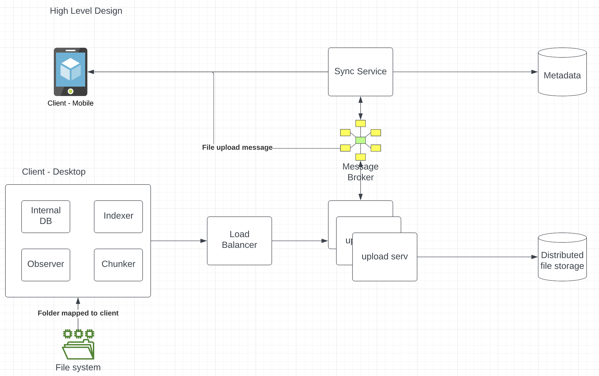

“Upload serv” will update file storage and also emits the metadata information, Sync service will listen to metadata and updates DB. Sync service will intimate all devices by emitting uploaded event and devices listening to uploaded events will start downloading the files from server and keep their file folder updated with new uploaded file. We have to use messaging broker to have asynchronous process for fault tolerance and making sure events are getting delivered to connected devices or whenever there back online.

Notes :

* 1. File is changed or not in local file system can be identified by calculating checksum and comparing with previously/Initially calculated checksum.
  2. Large file needs to be divided into chunks and every chunk will have chunkId(Indexer) and checksum for every chunk, with this design we can update exact chunk in server. Used for partial update of file instead of full update.

1. Design Youtube /Prime/ Net flix video streaming application.

High level Notes for self:

Users : Content creators / Viewers

CAP: Eventually consistency – S3/GCS kind of DFS for file storage & SQL(Preffered)/No SQL DB for metadata.

Scaling : Service are deployed over K8S kind of cluster & Video streaming happens over CDN

Partitioning/Sharding : Metadata Database can be partitioned or shareded based on userId so that his all videos can be retrieved quickly.

Functional Requirements:

* 1. Upload video
  2. Search Video
  3. View Video

Non Functional Requirements:

1. Upload seamlessly – Upload video chunk by chunk
2. View video - No/ Less Buffering
3. Low latency
4. High Availability
5. Eventual consistency
6. Scalable, Reliable

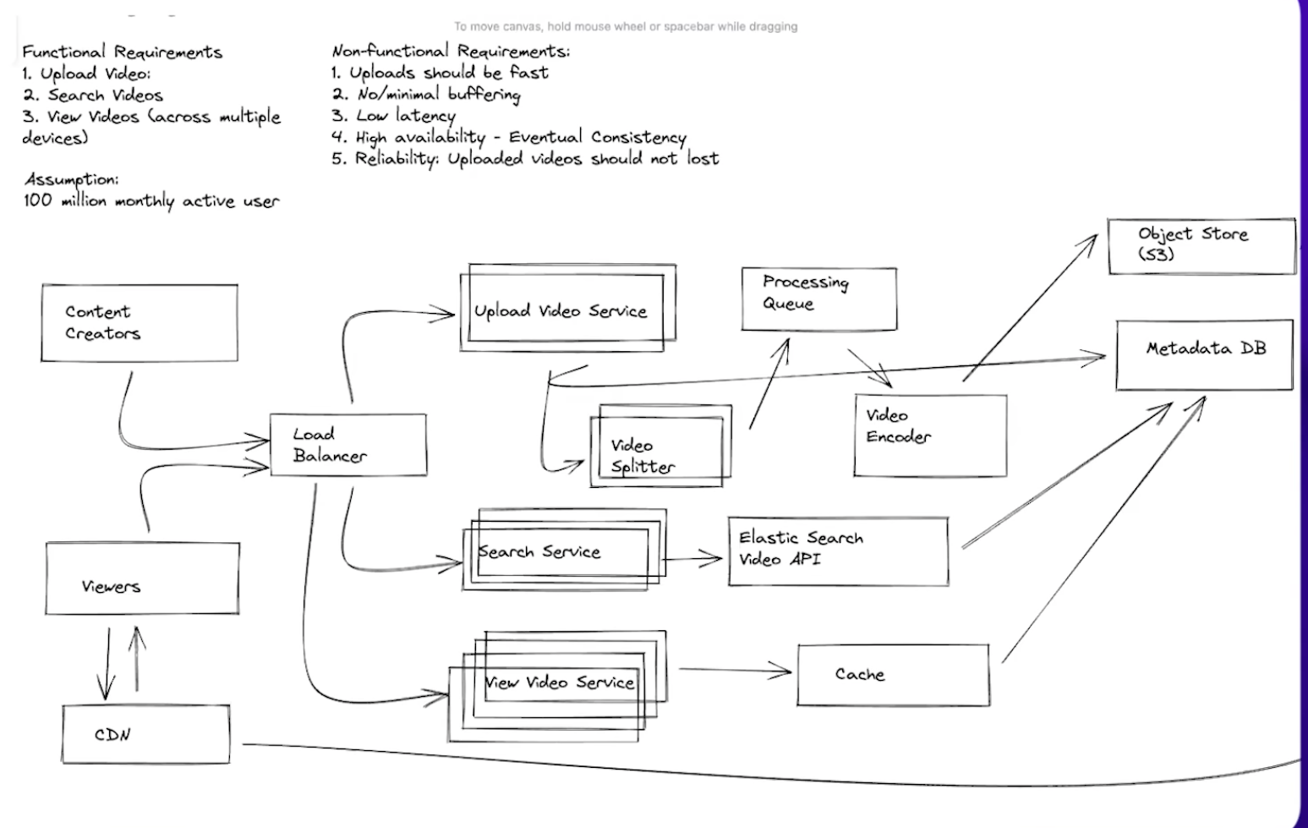

When a user requests a video from a streaming service(Video view service), the streaming service typically does not deliver the video directly to the user. Instead, it hands over the responsibility of delivering the video content to a Content Delivery Network (CDN).

Here are the typical steps involved in the handover of response to CDN for content delivery in a video streaming service:

User requests a video: When a user requests a video, the request is received by the streaming service's server. The server determines which video the user has requested and what quality level they are requesting.

Mapping the video location: The server then looks up the location of the requested video in its database. The location could be on the streaming service's own servers or on a CDN.

Assigning CDN: If the video is stored on a CDN, the streaming service's server selects the best CDN to deliver the video based on factors such as geographic location, server availability, and network capacity. The server then generates a request to the selected CDN to retrieve the video.

Retrieval from CDN: The CDN retrieves the video from its cache or origin server and sends it back to the streaming service's server.

Delivery to user: The streaming service's server then delivers the video to the user's device, typically using a streaming protocol such as HTTP Live Streaming (HLS) or Dynamic Adaptive Streaming over HTTP (DASH).

Throughout the process, the CDN is responsible for delivering the video content to the user in the most efficient and effective way possible, using a network of edge servers located around the world to minimize latency and improve the user's experience. The streaming service, on the other hand, is responsible for managing the user's request and selecting the best CDN to deliver the video based on various factors. Together, they provide a seamless and reliable video streaming experience for the user.

Improvements :

Video needs to be supported all formats & resolution, Hence this process can be executed by separate transcoder service Asynchronously.

1. Design Stock exchange system

Very High level design ☺ -

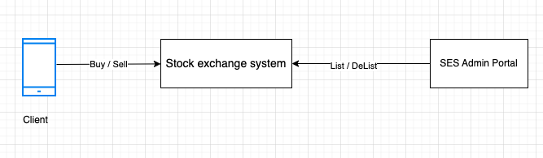

Functional Requirement –

* 1. Buy / Sell stocks(Scripts)
  2. Limit /Market order
  3. Partial matching order
  4. Valid till Market end(3:15PM)
  5. Payment integration.

Non Functional Requirement –

1. High Availability
2. High Consistency
3. Low latency
4. Scale -
   1. Orders per second – 50K(Buy/Sell) –

50k * 60 * 60 * 24 * 365 * 100Bytes (Transaction Data) – DB size

* 1. 5000(5K) Stocks listed

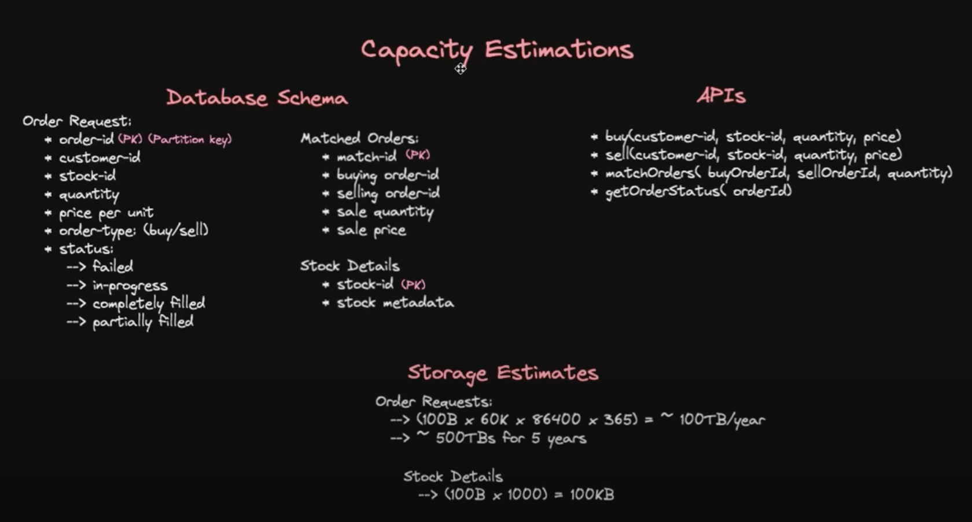

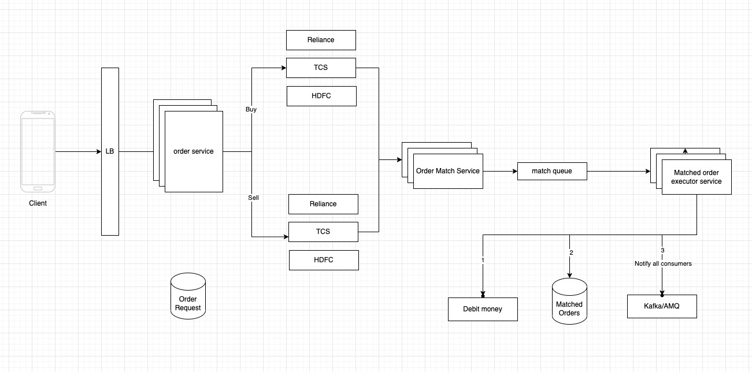

Buy Queues – Every stock will have its own buy /sell queue.

Ex:

Buy Queue - 8, 9 , 10

Sell Queue – 12, 11, 10

Matcher Service -

Buy orders can be max heap and sell queue can be min heap. Matcher service can listen to traded price by listening to traded price queue(Not mentioned above). Matcher service can pull top order from Buy Queue & Sell Queue and match them, if partial matched insert them again to their respective queue. Push the matched order to order execution queue.

Matched Orders executor service –

Once orders are matched they will be pushed to order execution queue and execution service picks the order, notified to listeners are broker apps via queue, insert matched orders table with matched details and payment service will debit /credit amount. If insufficient fund update the order accordingly and update order tables.

Expiry -

After trading window all the orders will be expired or ignored as per TTL of the order.

1. System design UBER / OLA

There are 2 users, Passenger(Demand) & Driver(Supply).

Functional Requirement

Passenger

* 1. See nearby drivers
  2. Input destination, get ETA & approx. price.
  3. Book a cab
  4. Track location – each other

Driver

1. Driver mark his availability – Start sending requests regularly to system with location.
2. Receive, trip details. Accept/Reject options
3. Track Location – each other

Non Functional

1. High Availability
2. Low latency
3. Scalable

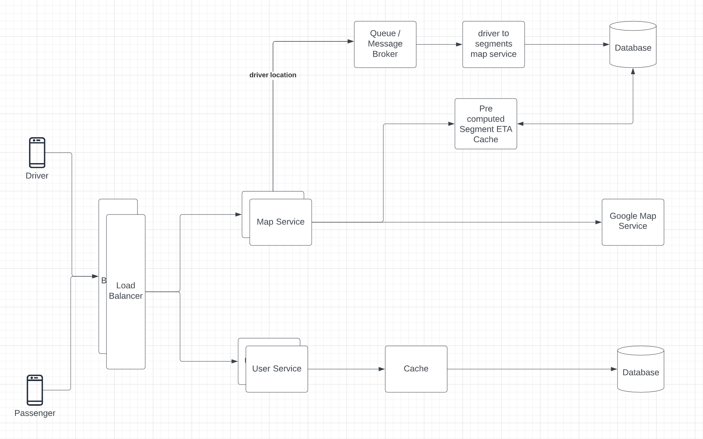

The main core concept of arriving on ETA between Passenger and Driver quickly.

1. First divide the map into segments of 1km radius. Every segment will have unique segment id and this data is fixed as map is constant.
2. Pre-calculate the ETA between adjacent segments and build cache.

Note : this ETA will not change very frequently as this data is almost fixed. There is a chance of ETA change between segments when new road is constructed etc, hence keep updating this ETA cache monthly / weekly once asynchronously.

1. When user looking for cabs, get all segments within 3KM/5KM(configurable) radius and add the segments ETA which fall under the radius and display.

Note: ETA(approx) is calculated by combining all segments which fall within radius hence it applies to all drivers within segments. Once cab is booked ETA is calculated depend on shortest path between Passenger & Driver using shortest path algorithms.

Map service

1. POST /seed-availability  
   Collect all drivers information(location, vehicle type etc) and keep updating segments with available driver information. This can be submitted for every 5sec(configurable)
2. GET /eta  
   Get the ETA & approx price of available cabs

User service

1. GET /info/{userId}  
   Get driver/passenger info.
2. POST /rate{userId}  
   Create travel rating of driver/Passanger

Etc..

1. Uber eats / Swiggy / Zomato – Food delivery Apps  
     
   Actors – User(Customer), Restaurant, Delivery Partner(Courier)

Functional Requirement

* 1. Login App
  2. Search for restaurants based on location
  3. Search for dish from selected restaurant menu
  4. Add dishes to cart – Cart will have items from same restaurant
  5. Place order
  6. Make Payment
  7. Receive Notification about progress

Non Functional

1. High availability
2. Scalable to cater huge user base

– Approx 50M Registered and 20M orders daily – (20*10^6)/(24*60*60) – 232 orders per second.

HLD

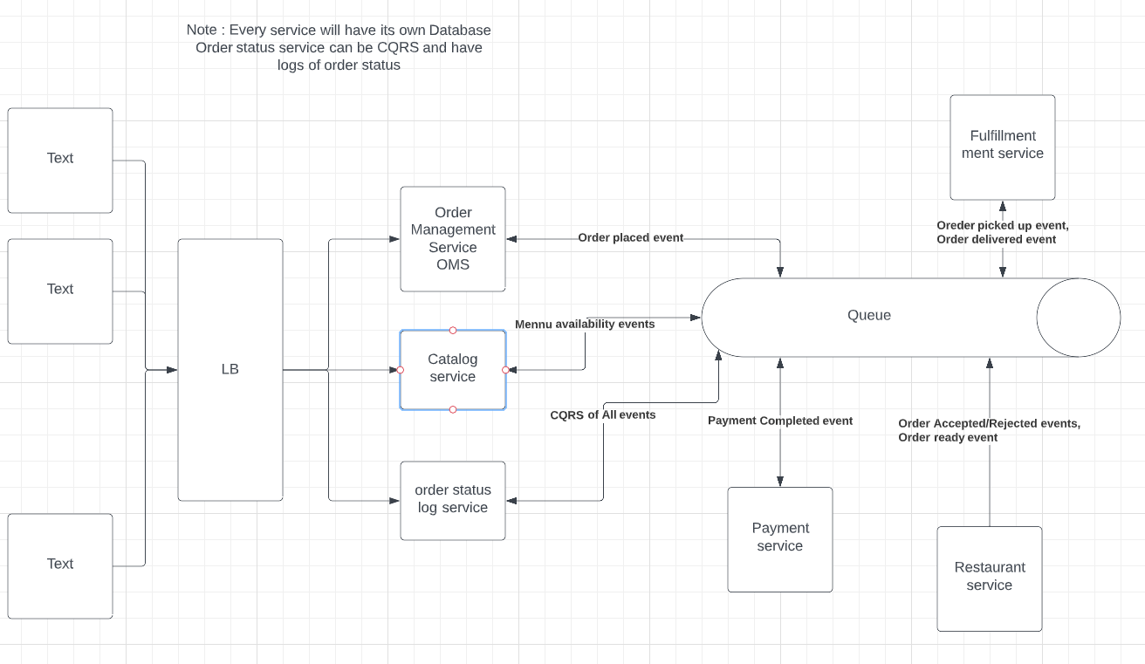

Design Rate Limiter

Design News feed system

Design Chat System

Design search Auto complete system

PayPal like payment system design